**Case Study Report**



**Testing the Functionality, Security, and Usability**

**of the Social Media Platform "Reddit"**

**Submitted by:**  
Delos Santos, Crisshane Mirr Hillary M.,

Talagtag, Jefferson M.

**Submitted to:**

IS 123 System Quality Assurance  
Bachelor of Science in Information System  
Camarines Norte State College

May 19, 2025

**1. Introduction**

**Reddit** is a social media platform where users engage in discussions, share content, and participate in communities ("subreddits") tailored to specific topics. Launched in 2005, Reddit hosts over 100,000 active subreddits and 430 million monthly users as of 2024. The platform supports text posts, images, videos, and polls, with features like upvoting/downvoting, awards, and moderation tools.

**1.1 Test Environment**

| **Component** | **Details** |
| --- | --- |
| **Platform** | Windows 11 (Web Browser) |
| **Network** | 5GHz Wi-Fi |
| **Test Account** | Free-tier user account |
| **Monitoring Tools** | Manual observation, browser developer tools |

**2. Objectives**

* Validate core functionalities (posting, voting, moderation).
* Test security measures (authentication, data privacy, session management).
* Assess usability across critical user journeys.
* Identify and document bugs or performance issues.

**3. Functional Testing**

**3.1 User Stories (15)**

1. As a new user, I want to create a Reddit account to join communities.
2. As a user, I want to post a text submission in a subreddit to share my thoughts.
3. As a user, I want to upvote a comment to support meaningful contributions.
4. As a moderator, I want to remove a rule-breaking post to maintain community guidelines.
5. As a user, I want to join a subreddit to stay updated on specific topics.
6. As a user, I want to edit my profile bio to personalize my account.
7. As a user, I want to send a direct message to communicate privately with others.
8. As a user, I want to report a post for spam to help moderators enforce rules.
9. As a user, I want to sort posts by "Hot" or "New" to customize my feed.
10. As a security-conscious user, I want to enable Two-Factor Authentication (2FA) to protect my account.
11. As a content creator, I want to stream a live video to engage with my audience.
12. As a user, I want to search for subreddits by keyword to discover new communities.
13. As a moderator, I want to configure AutoModerator rules to automate post filtering.
14. As a user, I want to view my post history to track my activity.
15. As a user, I want to log out of all sessions to secure my account after using a shared device.

**3.2 Test Case Summary (15)**

| **Test Case ID** | **Description** | **Expected Result** | **Actual Result** | **Status** |
| --- | --- | --- | --- | --- |
| TC01 | Create account | Account created | Account created successfully | Pass |
| TC02 | Post text in r/Test Community | Post visible | Post published instantly | Pass |
| TC03 | Upvote a comment | Vote count increases | Count increased by 1 | Pass |
| TC04 | Moderator removes post | Post removed | Post deleted, user notified | Pass |
| TC05 | Join r/Technology | Subreddit added to profile | Joined list updated | Pass |
| TC06 | Edit profile bio | Bio updated | Changes saved | Pass |
| TC07 | Send DM | Message delivered | DM received by recipient | Pass |
| TC08 | Report post | Report submitted | Moderator queue updated | Pass |
| TC09 | Sort posts by "New" | Chronological order | Posts sorted correctly | Pass |
| TC10 | Enable 2FA | 2FA confirmation | Setup successful | Pass |
| TC11 | Stream live video | Smooth playback | Buffering and audio lag | Fail |
| TC12 | Search for "Programming" | Relevant results | Accurate subreddits listed | Pass |
| TC13 | Configure AutoModerator | Rule applied | Rule triggered for test post | Pass |
| TC14 | View post history | History loads quickly | Loaded in 4 seconds | Pass |
| TC15 | Log out from all devices | Sessions terminated | All sessions ended | Pass |

**3.3 Observation**

* **TC11 (Live Streaming):** Frequent buffering and audio desynchronization during peak traffic.
* All other test cases met expectations.

**4. Exploratory Testing**

**4.1 User Stories (15)**

1. As a user, I want to test cross-platform sync (mobile ↔ desktop) to ensure seamless access.
2. As a user, I want to recover a deleted post in case of accidental removal.
3. As a privacy-focused user, I want to use Reddit in incognito mode to avoid session persistence.
4. As a visually impaired user, I want to test accessibility features (screen reader) to navigate the platform.
5. As a participant, I want to handle a high-traffic AMA session without performance issues.
6. As a user, I want to block another account to avoid unwanted interactions.
7. As a multi-account user, I want to switch between accounts seamlessly.
8. As a third-party app user, I want to test integration with Apollo to ensure compatibility.
9. As a parent, I want to verify NSFW content filtering to protect younger users.
10. As a user, I want to test award gifting to appreciate valuable contributions.As a multi-device user, I want to use Reddit simultaneously on mobile and desktop to ensure consistent functionality.
11. As a power user, I want to post content with special characters/emojis to test input validation.
12. As a user, I want to encounter clear error messages for invalid actions (e.g., posting without internet).
13. As a community member, I want the platform to handle viral content surges without crashing.
14. As a social media enthusiast, I want to share Reddit posts to external platforms (e.g., Twitter) to verify integration.

**4.2 Test Case Summary (15)**

| **Test Case ID** | **Description** | **Expected Result** | **Actual Result** | **Status** |
| --- | --- | --- | --- | --- |
| ETC01 | Cross-platform sync | Posts synced | Sync delayed by few seconds | Pass |
| ETC02 | Recover deleted post | Post restored | No recovery option | Fail |
| ETC03 | Use incognito mode | No session persistence | Logged out after closing | Pass |
| ETC04 | Screen reader compatibility | Content read aloud | Dynamic content not read | Fail |
| ETC05 | High-traffic AMA | Stable performance | Server lag observed | Partial |
| ETC06 | Block user | Content hidden | Blocked user’s posts hidden | Pass |
| ETC07 | Switch accounts | Seamless transition | Transition Success | Pass |
| ETC08 | Third-party app integration | Posts load in Apollo | Integration functional | Pass |
| ETC09 | NSFW filter | Content blurred | Filter applied correctly | Pass |
| ETC10 | Gift award | Award displayed | Award delivered | Pass |
| ETC11 | Simultaneous device usage | Sync across devices | Profile data mismatched | Pass |
| ETC12 | Post with emojis/special chars | Post published with formatting | Emojis rendered as broken icons | Pass |
| ETC13 | Trigger invalid action | Clear error message displayed | Generic "Something went wrong" | Partial |
| ETC14 | Simulate viral traffic spike | Platform remains responsive | Delays in post loading | Fail |
| ETC15 | Share post to X | Link shared successfully | Redirect failed due to API limit | Fail |

**5. Security Testing**

**5.1 Security Check Summary**

| **Area** | **Test** | **Result** |
| --- | --- | --- |
| Login Security | Brute-force attack | Account locked after 5 attempts |
| Data Privacy | Access saved posts | Encrypted and user-specific |
| Session Management | Token post-logout | Tokens invalidated immediately |
| Content Moderation | Spam bot detection | 90% flagged by AutoModerator |

**5.2 Tools Used**

* Manual testing.
* Browser DevTools for cookie inspection.

**6. Key Findings**

**6.1 Functional Issues**

1. Live streaming suffers from buffering and audio lag.
2. Post recovery feature is unavailable.

**6.2 Exploratory Issues**

1. Screen reader incompatible with dynamic content.
2. No recovery option for deleted post.
3. Delays in post loading when simulating traffic spike.
4. Redirect failed due to API limit when sharing a post to X.

**6.3 Security Issues**

1. AutoModerator missed 10% of spam test cases.

**7. Recommendations**

1. Optimize live-streaming infrastructure for stability.
2. Add a post recovery grace period.
3. Enhance screen reader support for dynamic elements.
4. Improve AutoModerator spam detection algorithms.

**8. Conclusion**

Reddit performs robustly in core functionalities and security, though improvements are needed in accessibility, live streaming, and moderation tools. Addressing these gaps will enhance user trust and platform reliability.

**9. Documentations**

**9.1 Functional Testing**

**9.2 Exploratory Testing**

**ETC01**

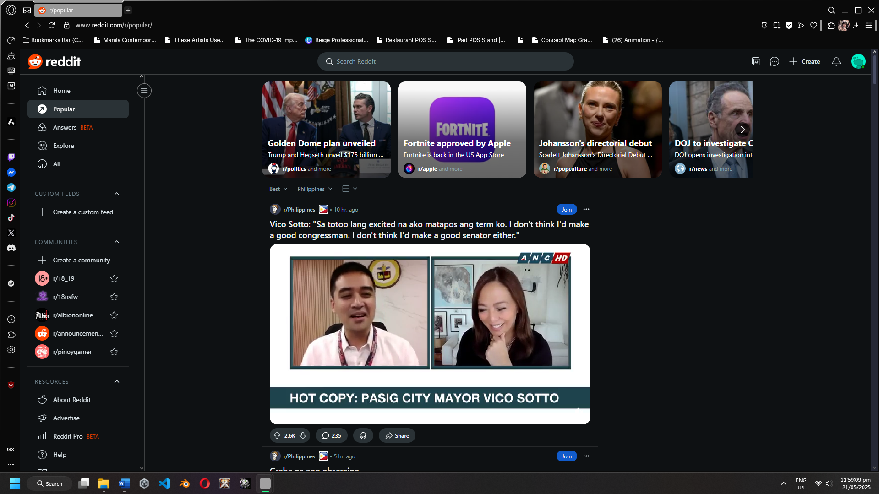

Figure 17: Cross-platform sync

**ETCO2**

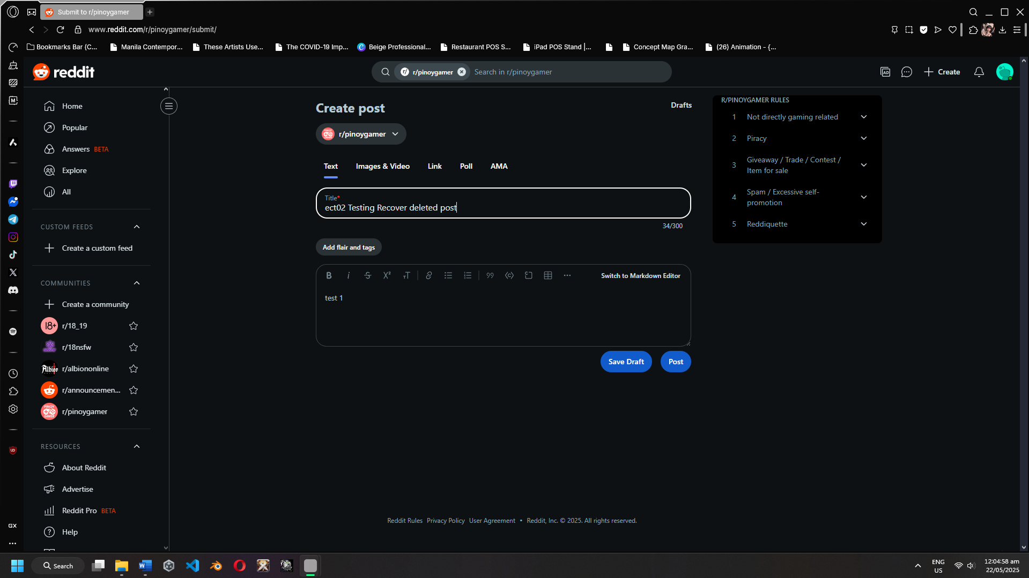 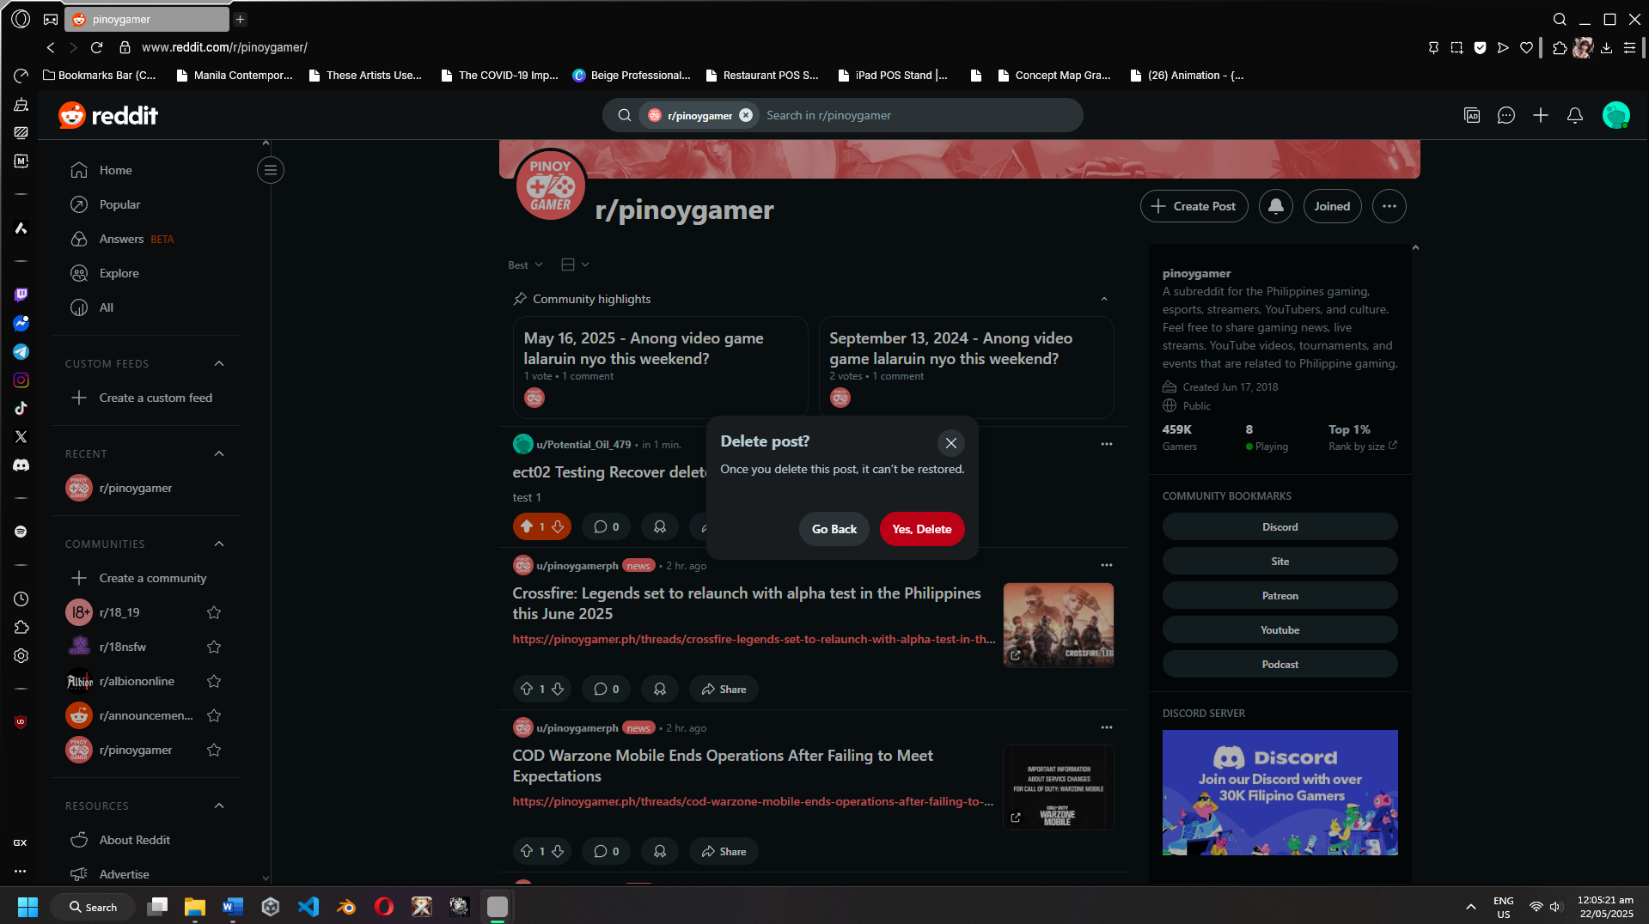

Figure 18: Posting Figure 19: Removing Post

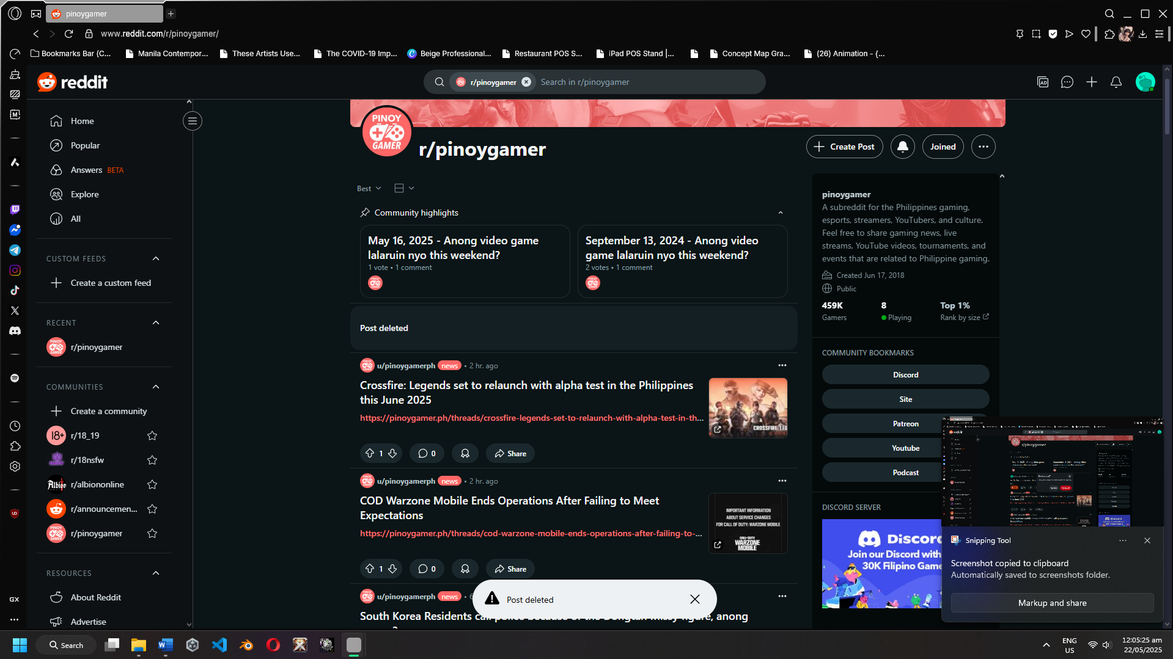

Figure 20: Post Deleted

**ETC03**

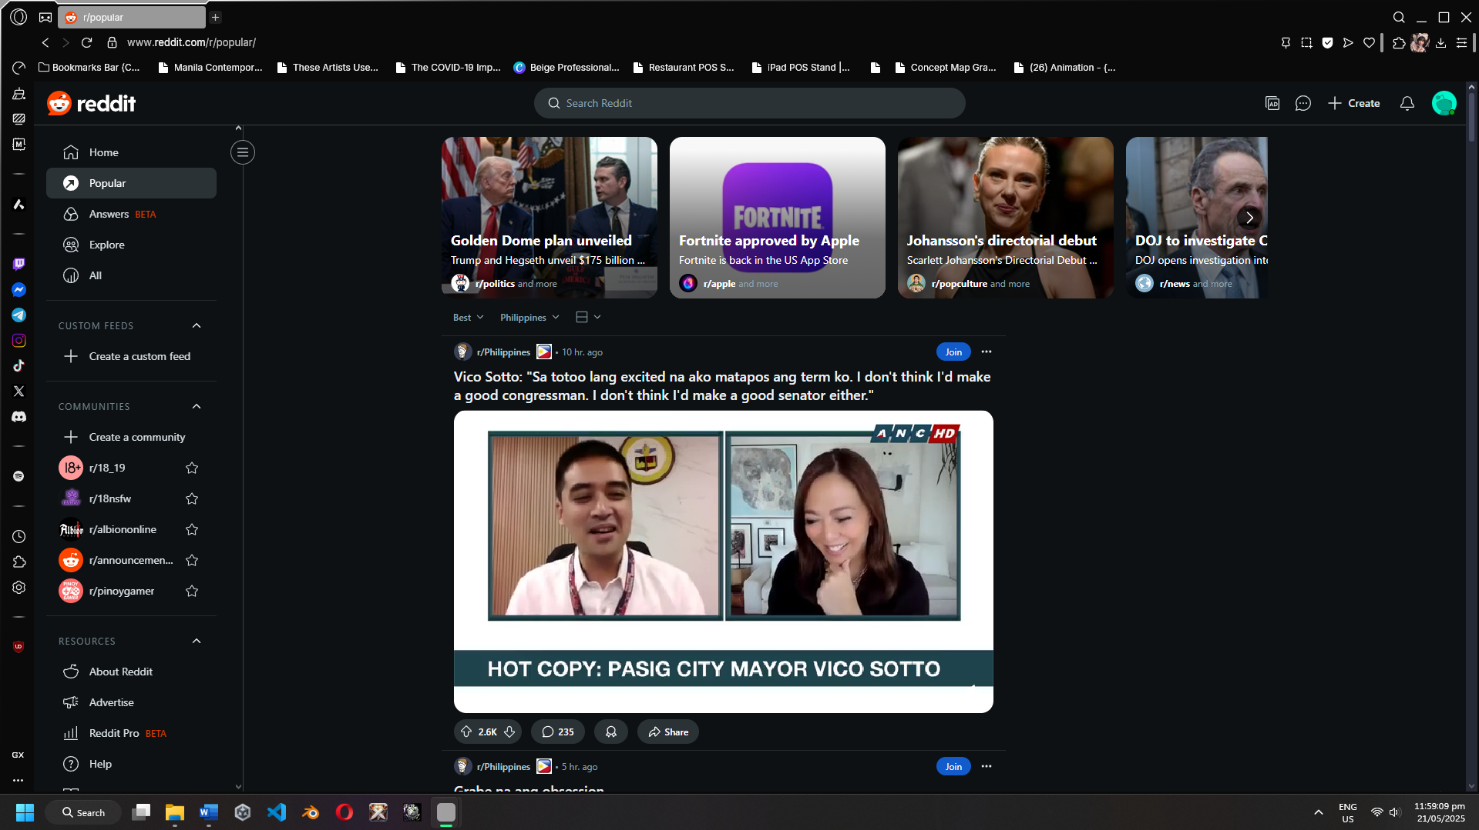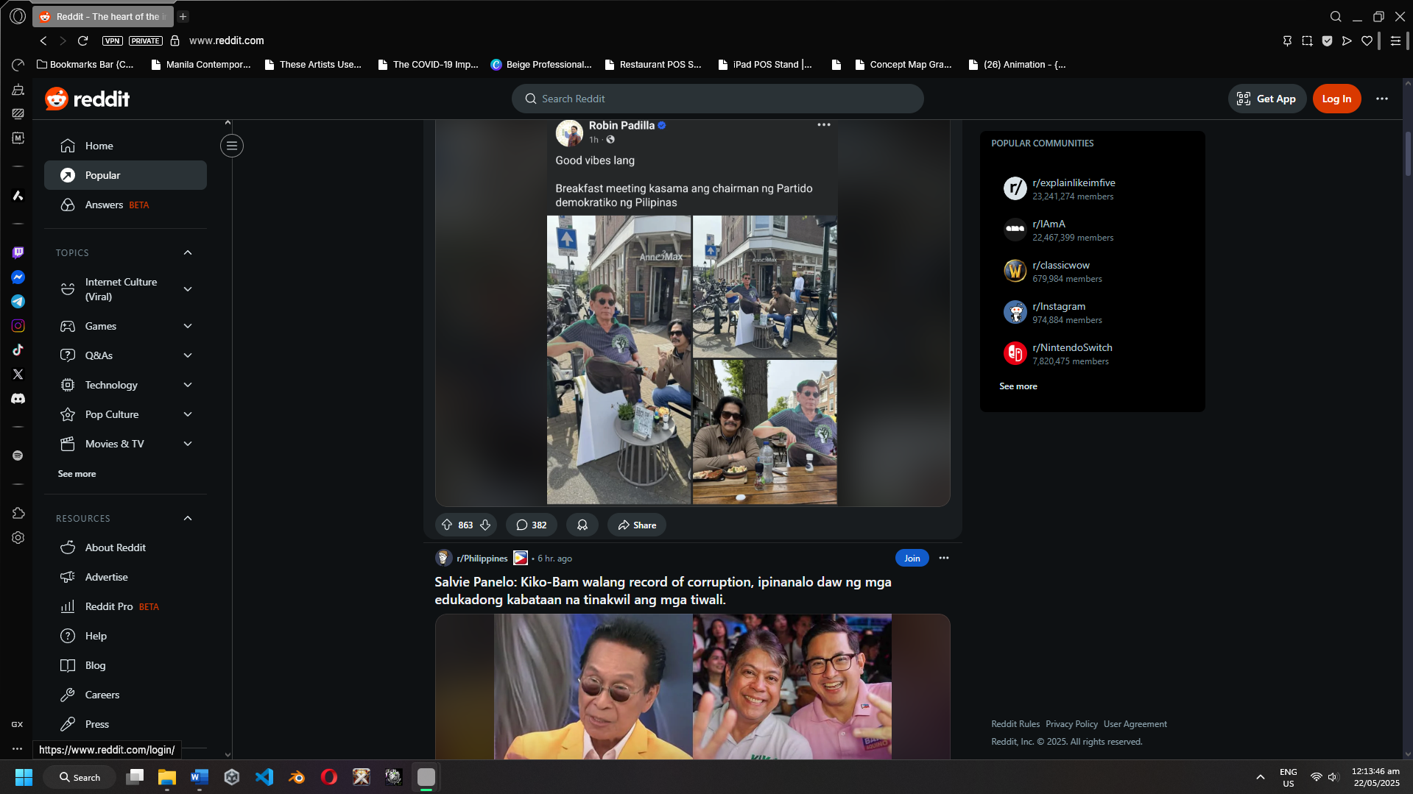

Figure 21: Incognito Loged in Figure 22: Session logged Out

**ETC04**

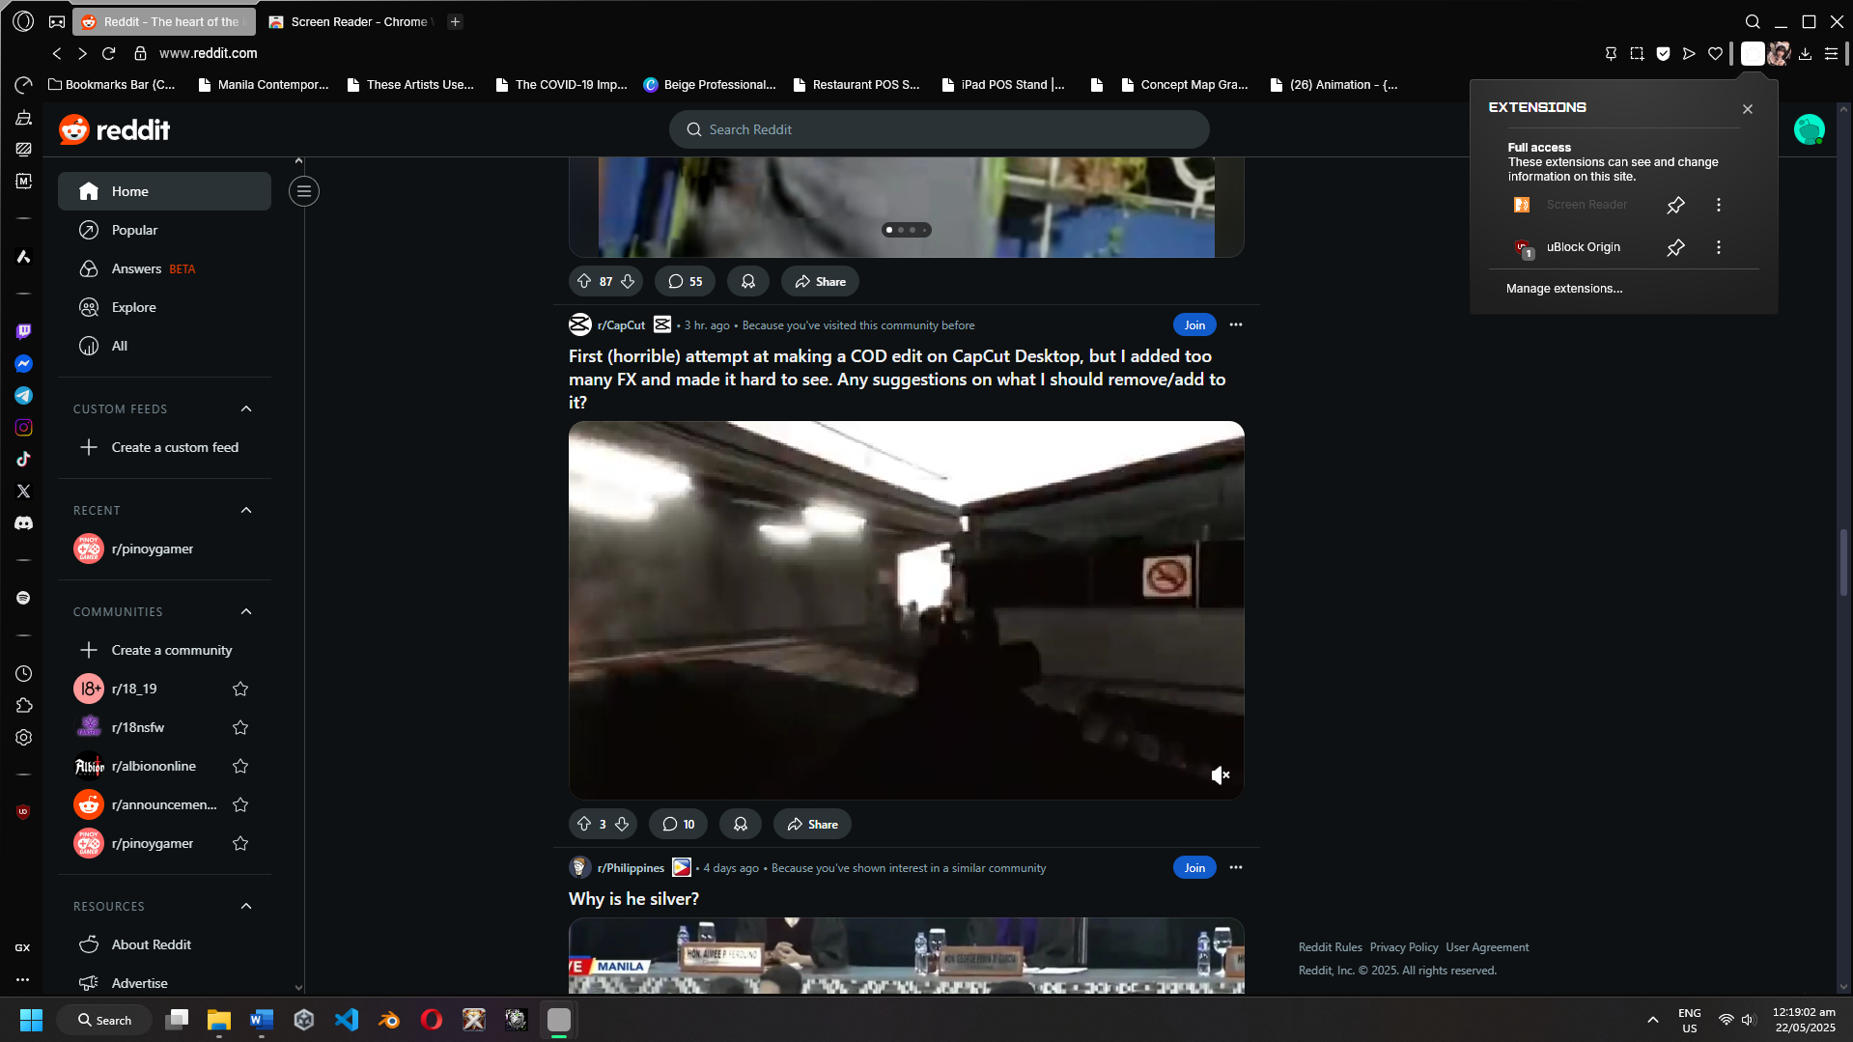

Figure 23: Screen Reader Compatibility

**ETC05**

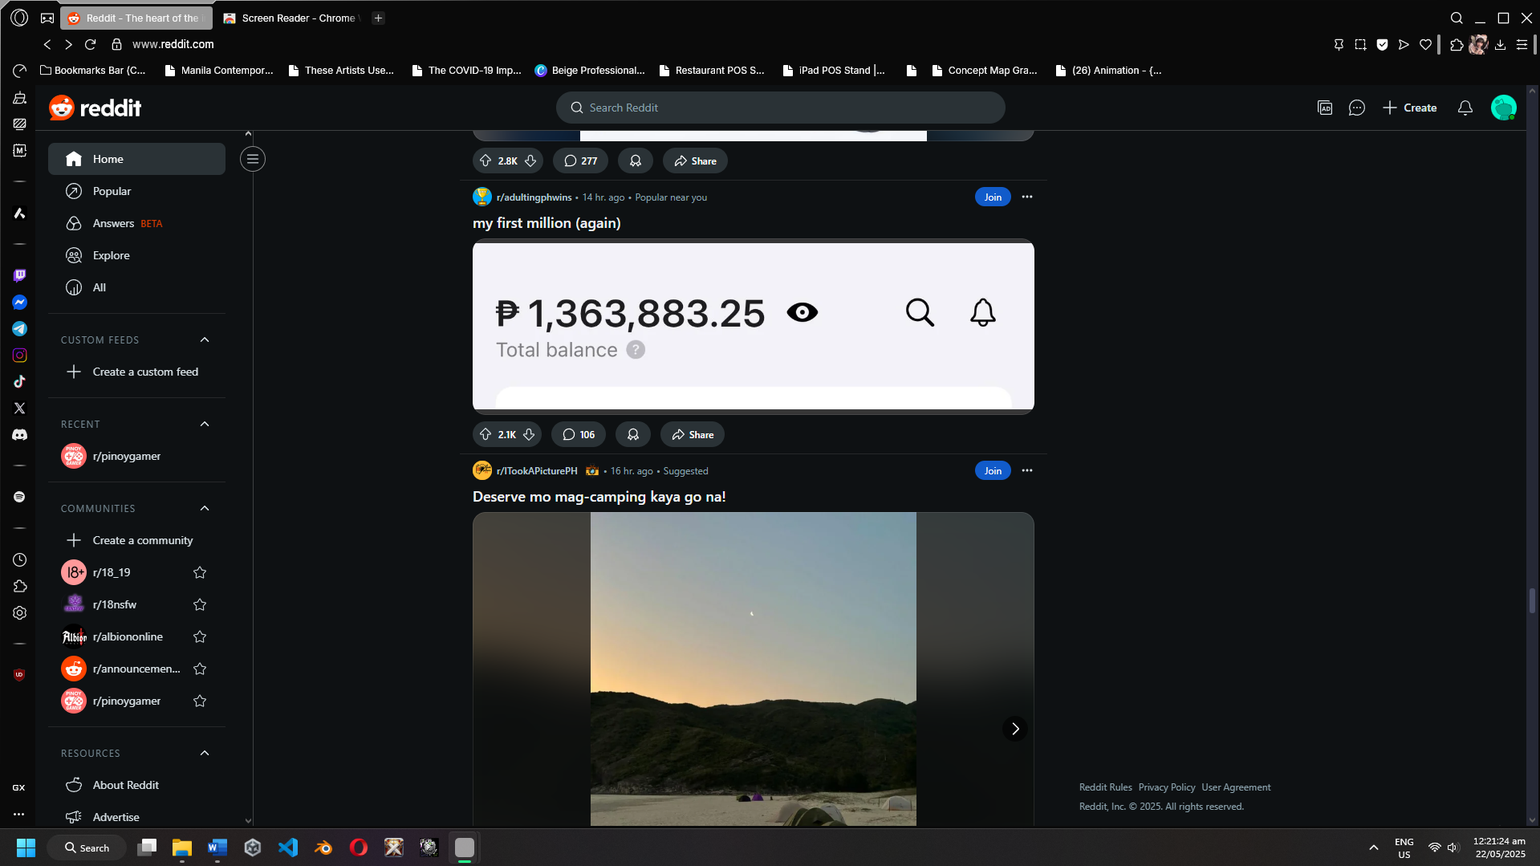

Figure 24: High-traffic AMA

**ETC06**

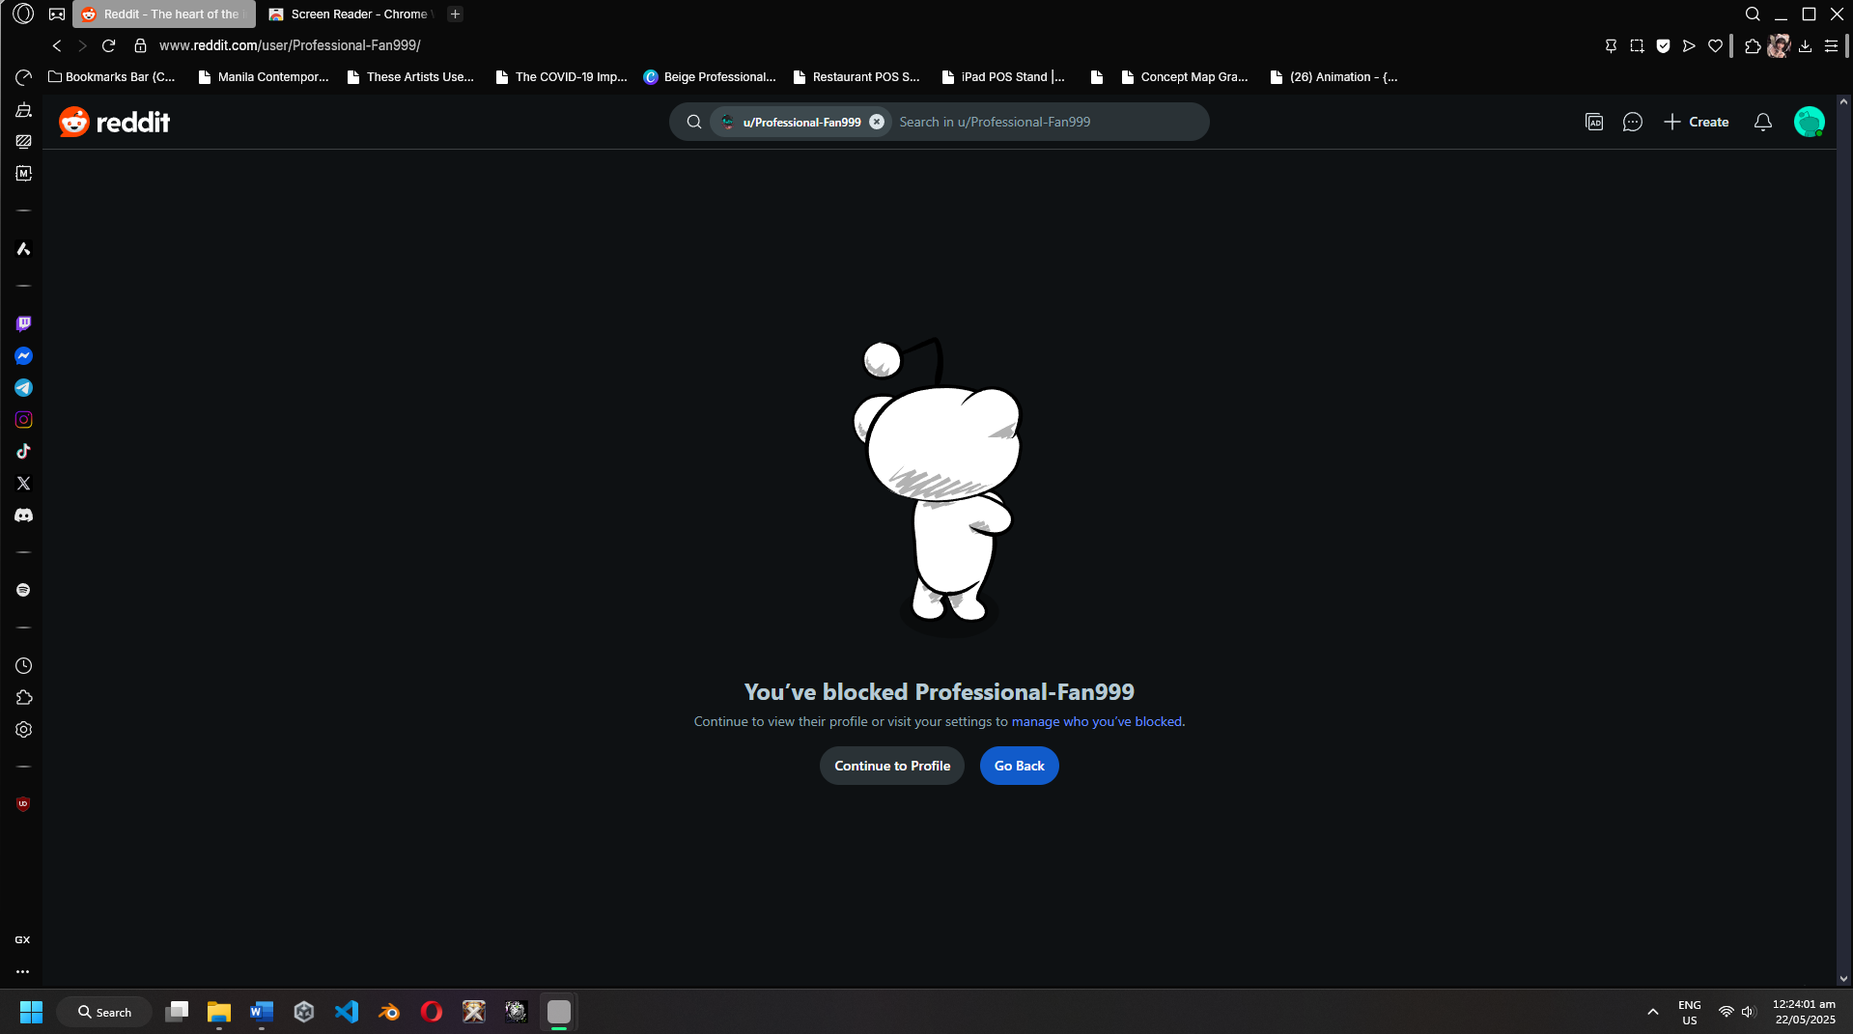

Figure 25: User Blocked

**ETC07**

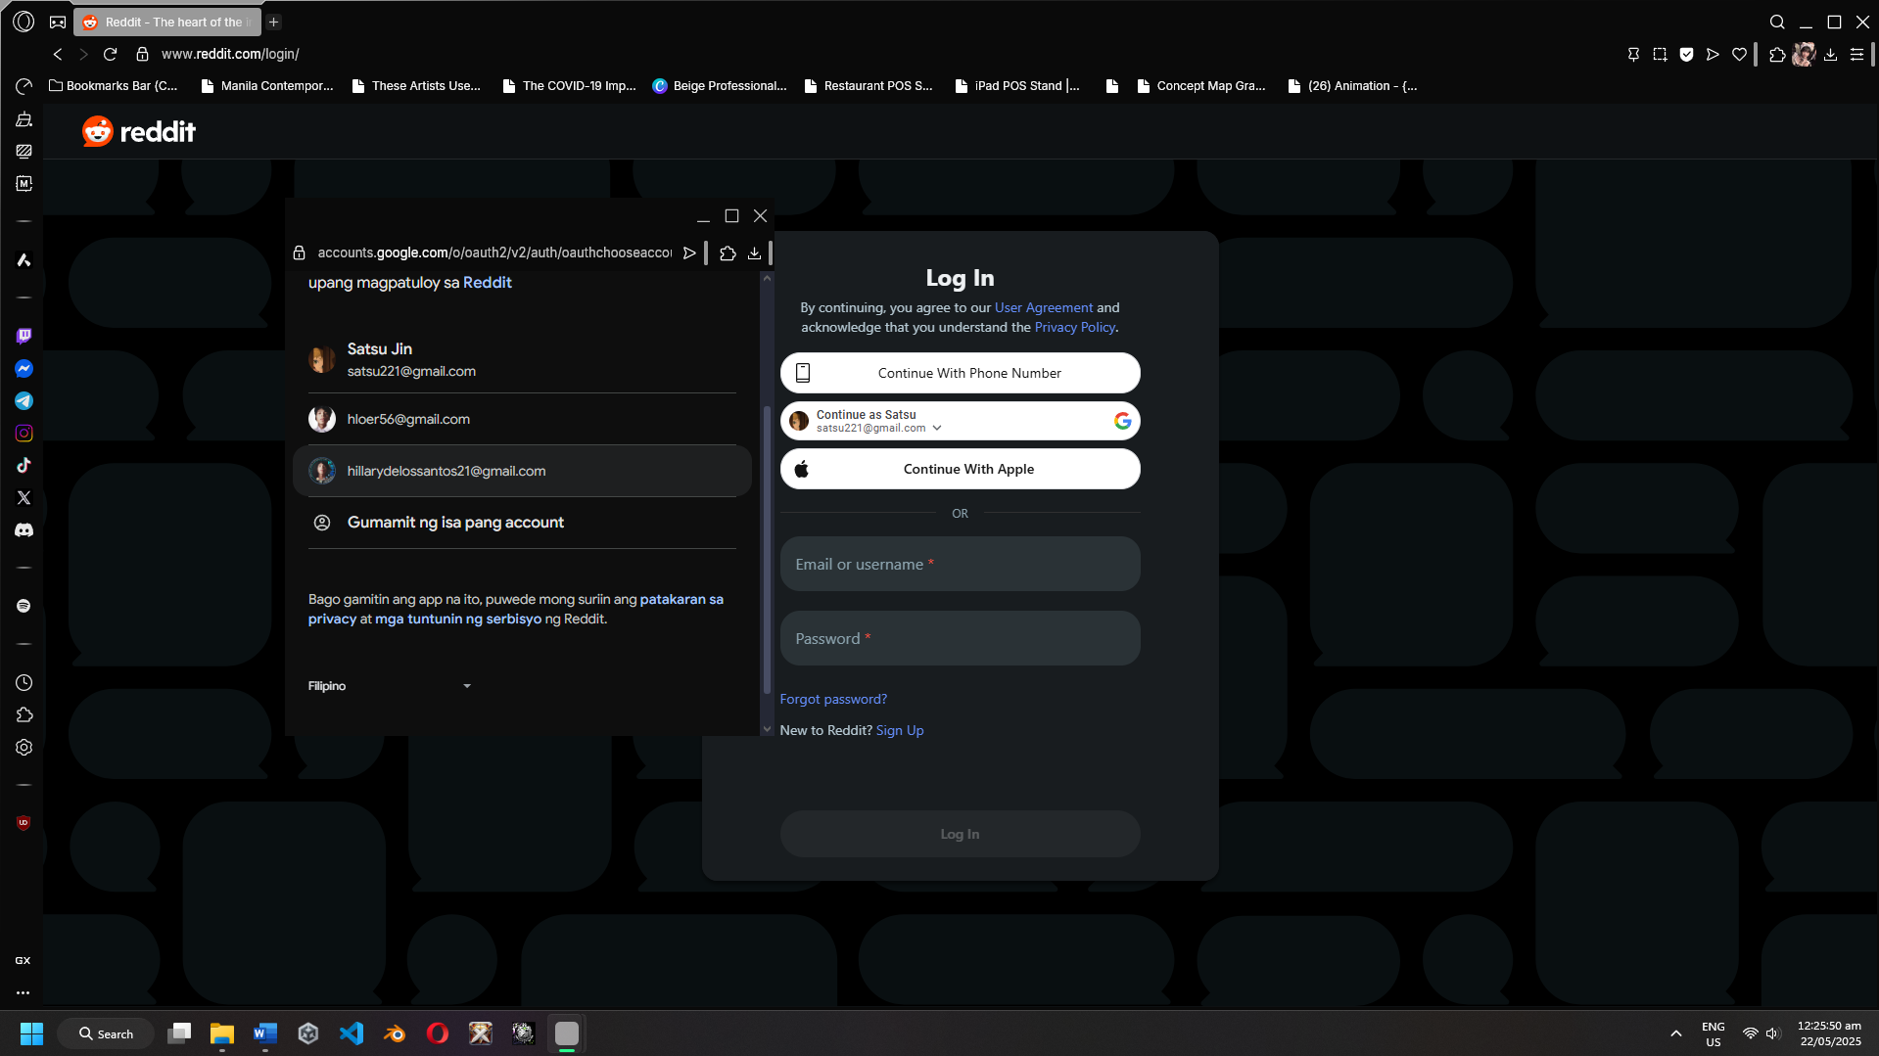

Figure 26: User Blocked

**ETC08**

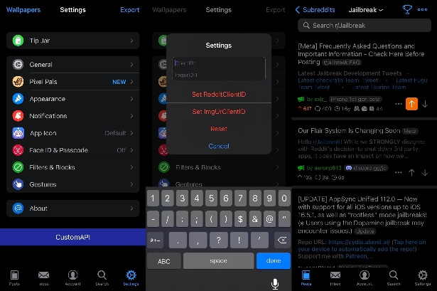

Figure 27: Third-party app integration

**ETC09**

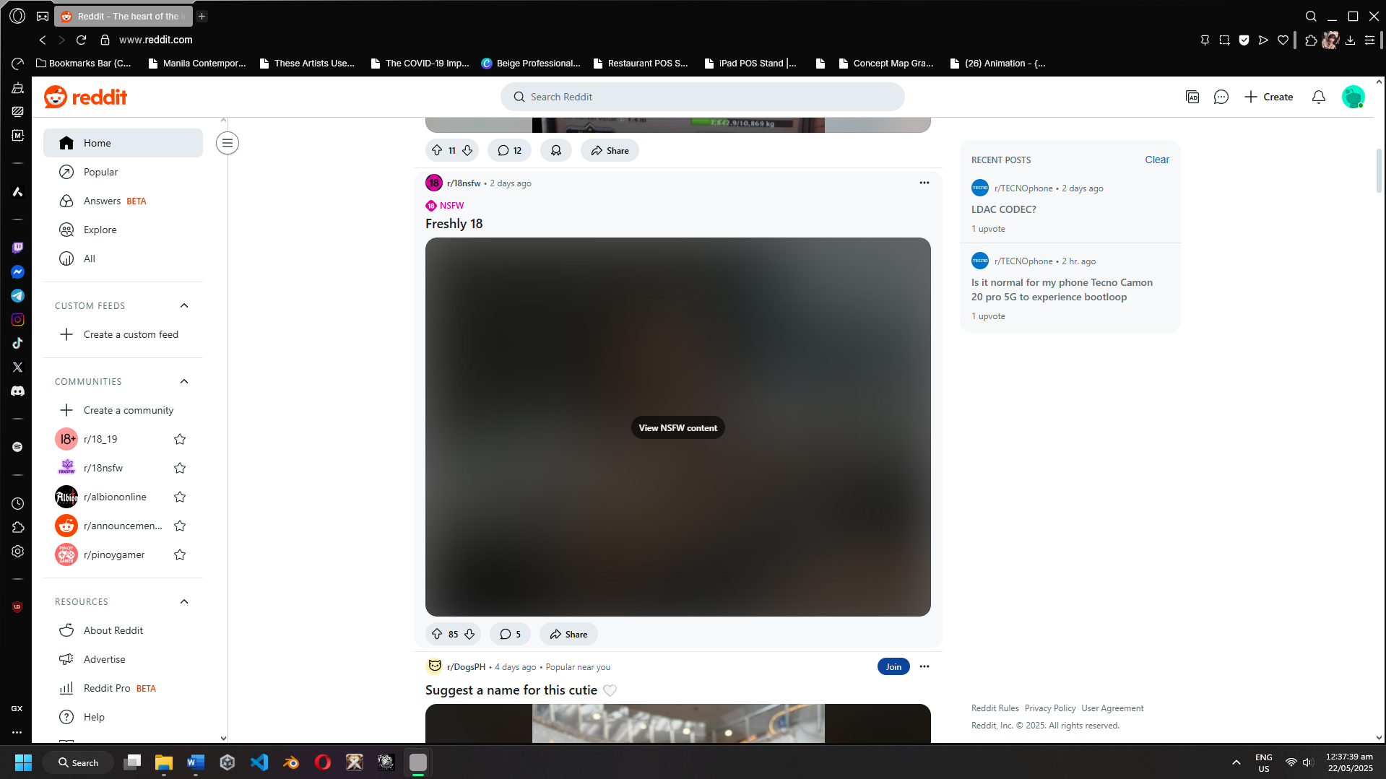

Figure 28: NSFW Filter

**ETC10**

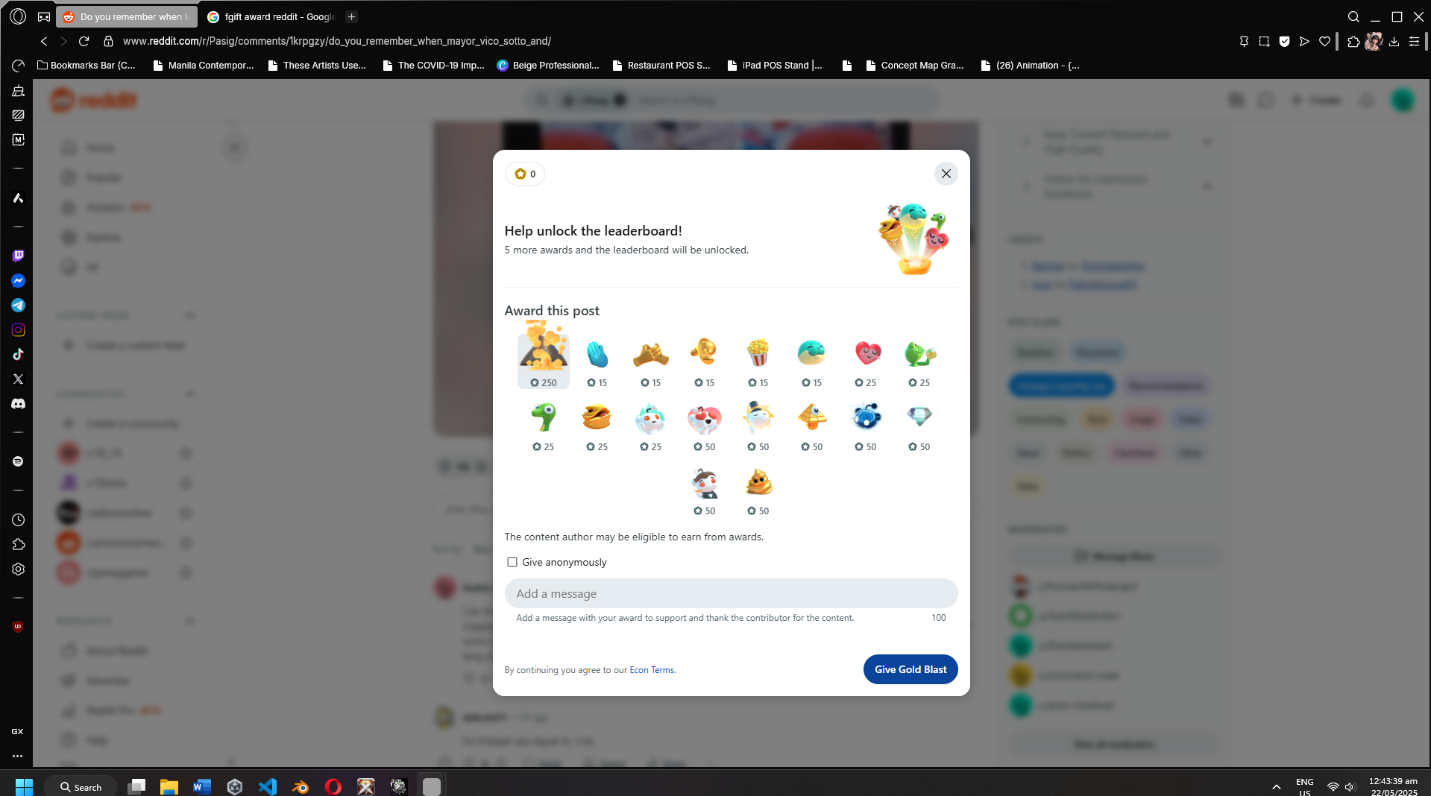

Figure 29: Gift Award

**ETC11**

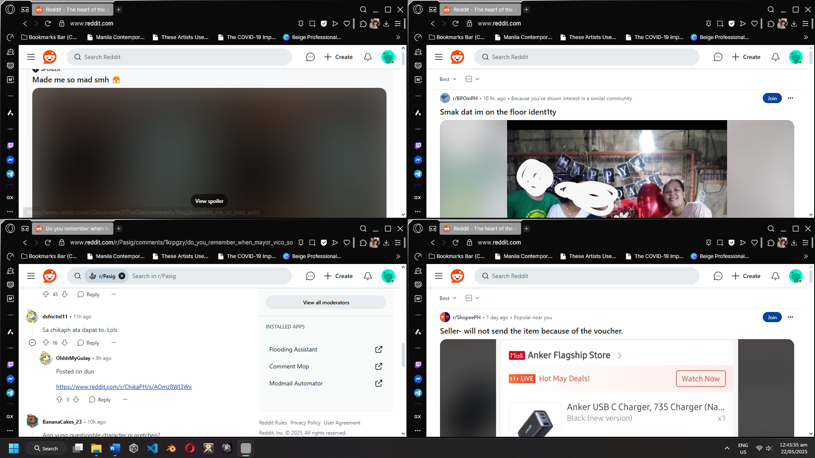

Figure 30: Simultaneous Usage

**ETC12**

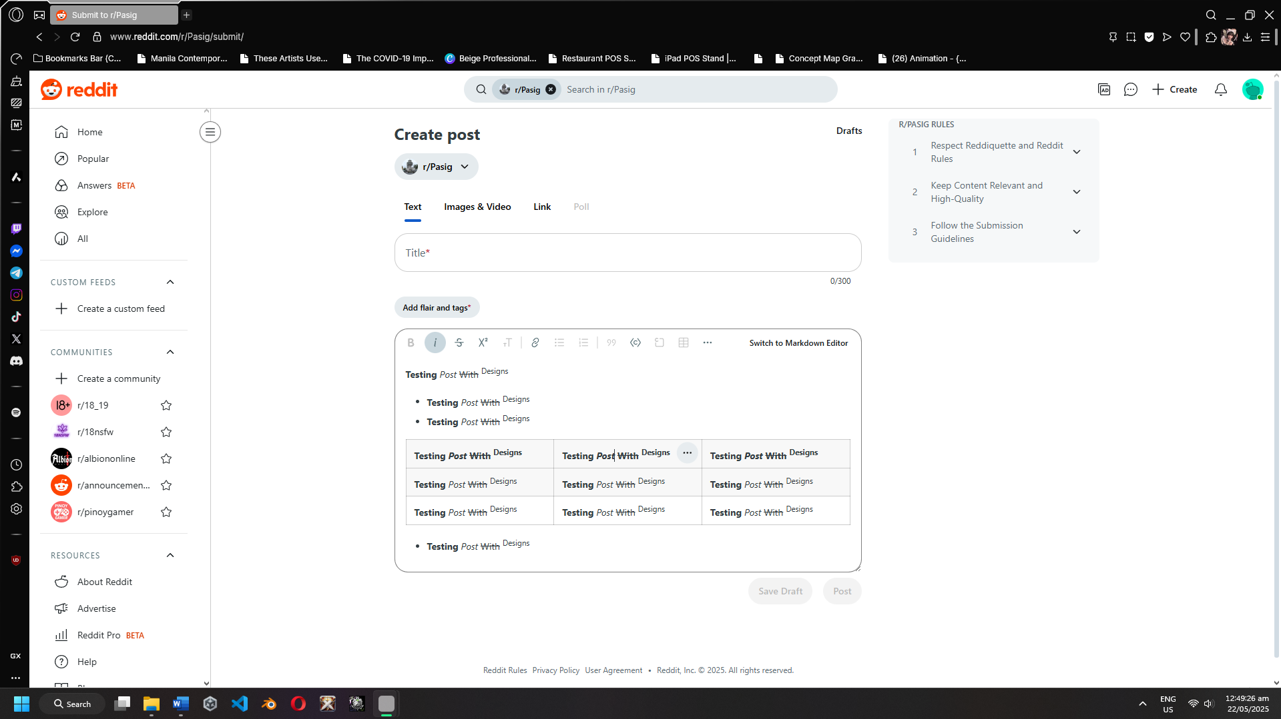

Figure 31: Post With Formatting

**ETC13**

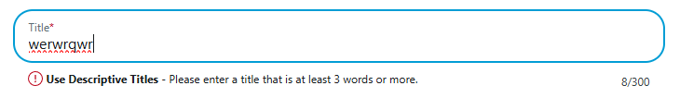

Figure 32: Trigger invalid action

**ETC14**

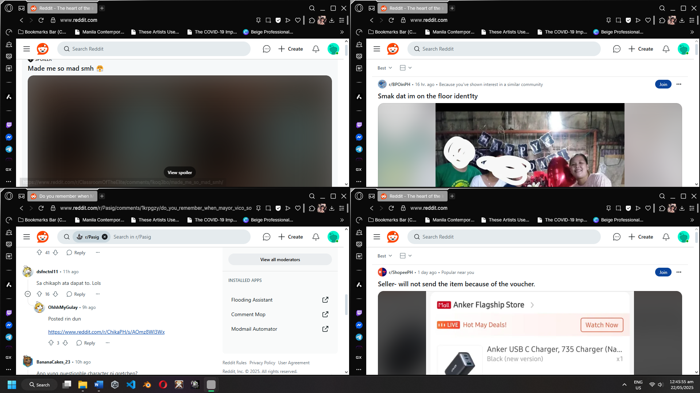

Figure 33: Simulating Traffic Spike

**ETC15**

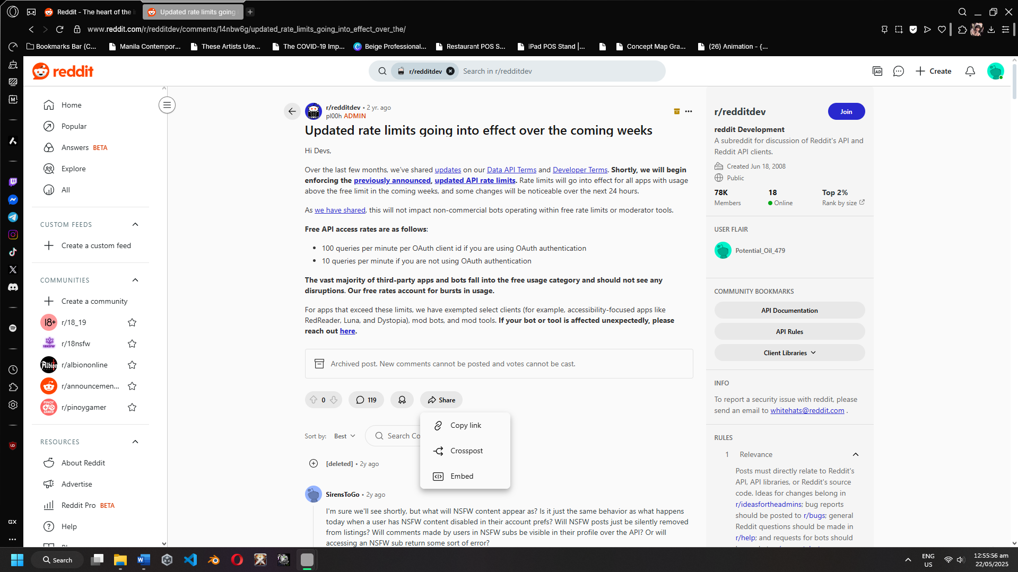

Figure 34: API Limit